**1. Import cleaned data and necessary libraries**

<class 'pandas.core.frame.DataFrame'>

Index: 2235 entries, 0 to 2239

Data columns (total 46 columns):

# Column Non-Null Count Dtype

--- ------ -------------- -----

0 ID 2235 non-null int64

1 Year_Birth 2235 non-null int64

2 Income 2235 non-null float64

3 Kidhome 2235 non-null int64

4 Teenhome 2235 non-null int64

5 Dt_Customer 2235 non-null datetime64[ns]

6 Recency 2235 non-null int64

7 MntWines 2235 non-null int64

8 MntFruits 2235 non-null int64

9 MntMeatProducts 2235 non-null int64

10 MntFishProducts 2235 non-null int64

11 MntSweetProducts 2235 non-null int64

12 MntGoldProds 2235 non-null int64

13 NumDealsPurchases 2235 non-null int64

14 NumWebPurchases 2235 non-null int64

15 NumCatalogPurchases 2235 non-null int64

16 NumStorePurchases 2235 non-null int64

17 NumWebVisitsMonth 2235 non-null int64

18 AcceptedCmp3 2235 non-null int64

19 AcceptedCmp4 2235 non-null int64

20 AcceptedCmp5 2235 non-null int64

21 AcceptedCmp1 2235 non-null int64

22 AcceptedCmp2 2235 non-null int64

23 Response 2235 non-null int64

24 Complain 2235 non-null int64

25 Number_children 2235 non-null int64

26 Age 2235 non-null int64

27 total_spending 2235 non-null int64

28 total_purchases 2235 non-null int64

29 Education 2235 non-null float64

30 Marital_Status_Absurd 2235 non-null float64

31 Marital_Status_Alone 2235 non-null float64

32 Marital_Status_Divorced 2235 non-null float64

33 Marital_Status_Married 2235 non-null float64

34 Marital_Status_Single 2235 non-null float64

35 Marital_Status_Together 2235 non-null float64

36 Marital_Status_Widow 2235 non-null float64

37 Marital_Status_YOLO 2235 non-null float64

38 Country_AUS 2235 non-null float64

39 Country_CA 2235 non-null float64

40 Country_GER 2235 non-null float64

41 Country_IND 2235 non-null float64

42 Country_ME 2235 non-null float64

43 Country_SA 2235 non-null float64

44 Country_SP 2235 non-null float64

45 Country_US 2235 non-null float64

dtypes: datetime64[ns](1), float64(18), int64(27)

memory usage: 820.7 KB

None

# 2. Top-performing products and low-revenue products.

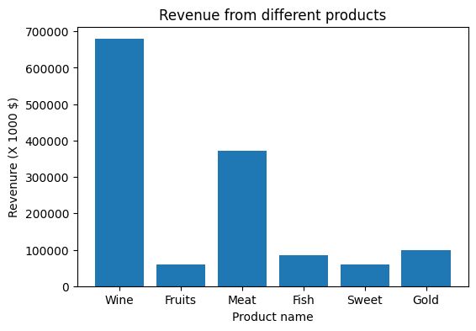

# 3. Relationship between age and last campaign acceptance.

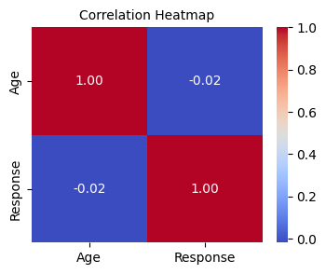

# 4. Spending patterns by number of children

total_spending

Number_children

0 701269

1 533094

2 103544

3 14554

Text(0, 0.5, 'Familiy total expendure')

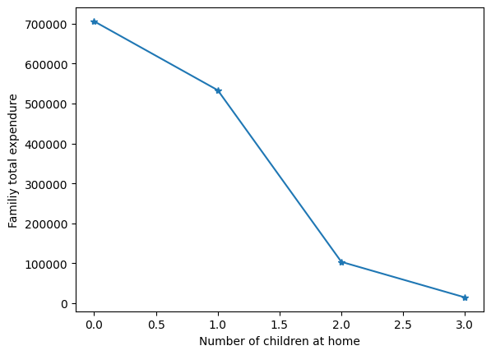

# 5. Education levels among customers with complaints.

Complain

Education

0.0 3

1.0 0

2.0 14

3.0 2

4.0 1

Text(0, 0.5, 'Familiy total expendure')

